Deployment Tutorial For
Stellar-CrossChain Test Envirnment

Preparation
For this project, in addition to running the Bridge client locally (section 6), we recommend that all other backend services (sections 2 to 5) be built on the same cloud server.

Cloud Server

System Requirement
- Operation System：Ubuntu
- Node： v20.19.2

Token Acquisition

Test Token for Polygon
Go to the https://faucet.polygon.technology/ page， you can apply for Amoy POL and we recommend 5 POL at least for testing：
- 1.5 POL for owner account to deploy polygon contracts；
- 2 POL for leader agent account to submit polygon transactions；
- Other else will be used as fee for polygon extension wallet.

Test Token for Ethereum
Go to the faucet https://www.alchemy.com/faucets/ethereum-sepolia, and then can request tokens：
- For eth contracts deployment；
- For leader agent to submit eth transactions；
- For eth extension wallet.

Chrome Extension Wallet
- Wallet for Ethereum
For example： Rabby Wallet

- Wallet for Polygon
For example： Rabby Wallet

Infura Project ID
Go to the https://developer.metamask.io/ , you need to apply a Infura Project ID for ethereum contract deployment.

Keystores
Since the MPC security mechanism for this project, you will need to prepare several polygon keystores for the Leader and Follower agents.
NOTE: The password of all these keystores must keep the same.

Utils for Accounts
During the follow operations, you will configure these cross-chain services with the publicKey、privateKey and address of these keystores, as well as their mapping address on the Stellar chain.
With the “accountUtil.js” we provide, you can get all these account information from keystore files:
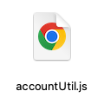

Test coins for Accounts
Based on the MPC mechanism, the Leader Agent is designated to build and submit transactions, so the Leader‘s account need to hold both Polygon and Stellar test coins.
You will transfer polygon test coins to the Leader agent’s polygon address, and also transfer the stellar test coins to the Leader agent’s Stellar mapping address, which you can get from “accountUtil.js” .

Contracts Deployment

Setting Up Hardhat Contract Development Environment
The Polygon contract scripts of this project are based on the Hardhat. You will need to set up a Hardhat-based environment for compiling and deploying Polygon contracts.
You can refer to the official Hardhat documentation for setup instructions:(node version is require v20+)
https://hardhat.org/hardhat-runner/docs/getting-started

Deployment of Message Contracts

The Deployment of Polygon Message Contract
You can refer to the technical documentation of this project about the polygon chain Message contract:
./contracts/contracts_polygon/message-bridge-contracts/README.md
NOTE：
First of all, you will take an account as contract owner to deploy polygon contract. And then:
export PK=0x<owner_private_key>

2.1.2.1 Install Dependency
cd ./contracts/contracts_polygon/message-bridge-contracts/
yarn

2.1.2.2 Compile Contract
yarn hardhat compile

2.1.2.3 Update Script
After compile contracts, please change directory to “./contracts/contracts_polygon/message-bridge-contracts/scripts/”，and update the script “deploy_testnet.js” as follows：
- The owner's account used to deploy the contract (it is recommended that the account should hold 1.5 POL);
- Based on the keystore prepared in Section 1.4, configure its corresponding address as the MPC signing address;
- The threshold of the number of valid signatures of MPC.
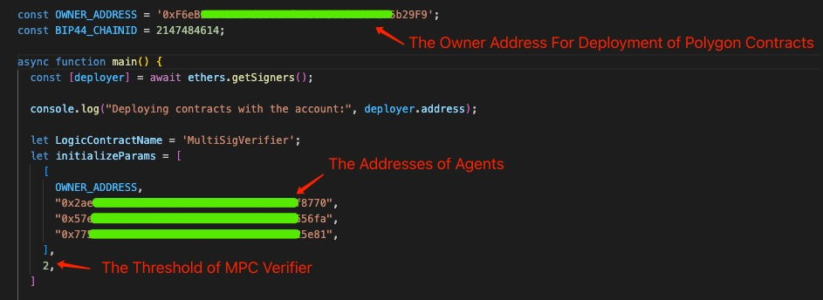

2.1.2.4 Deploy Contract
After the configuration information is confirmed above, then execute the
following command:
yarn hardhat --network polygonAmoy run scripts/deploy_testnet.js

The deployed contract addresses will be seen in the output of this script, and then you should record these information which need to be filled in the configure file of services.

NOTE:
Please make sure you save contract addresses you deploy.

The Deployment of Ethereum Message Contract
This step is similar to 2.2.1, just open a new terminal just for Ethereum contracts. When you run the scripts for ethereum contracts, make sure you have exported the PK && INFURA_PROJECT_ID in your cmd terminal:

export PK=0x<owner_private_key>
export INFURA_PROJECT_ID=<your-infura-project-id>

2.2.2.1 Install Dependency
cd ./contracts/contracts_ethereum/message-bridge-contracts/
yarn

2.2.2.2 Compile Contract
yarn hardhat compile

2.2.2.3 Update Script
After compile contracts, please change directory to “./contracts/contracts_ethereum/message-bridge-contracts/scripts/”，and update the script “deploy_testnet.js” as follows：
- The owner's account used to deploy the contract (it is recommended that the account should hold Sepolia Eth Test Token);
- Based on the keystore prepared in Section 1.4, configure its corresponding address as the MPC signing address;
- The threshold of the number of valid signatures of MPC.

2.2.2.4 Deploy Contract
After the configuration information is confirmed above, then execute the
following command:
yarn hardhat --network sepolia run scripts/deploy_testnet.js

The deployed contract addresses will be seen in the output of this script, and then you should record these information which need to be filled in the configure file of services.

The Deployment of Token CrossChain Contracts From Polygon to Ethereum

In order to support the Polygon’s native token cross to Ethereum, you need to deploy the TokenHome contract in Polygon and it’s associated TokenRemote contract in Ethereum.
So in this step, you will deploy and configure contracts in both polygon && ethereum.

The deployment of the TokenHome contract in Polygon

2.3.1.1 Install Dependency
cd ./contracts/contracts_polygon/token-contracts/
yarn

2.3.1.2 Compile Contract
yarn hardhat compile

2.3.1.3 Update Script
After compile contracts, please change directory to “./contracts/contracts_polygon/token-contracts/scripts/”，and update the script “deploy_tokenHome_byProxy.js” as follows：
- The owner address used to deploy the contract;
- The address of message bridge contract you have deployed in 2.2.1;
- The erc token address you want to crosschain in Polygon.
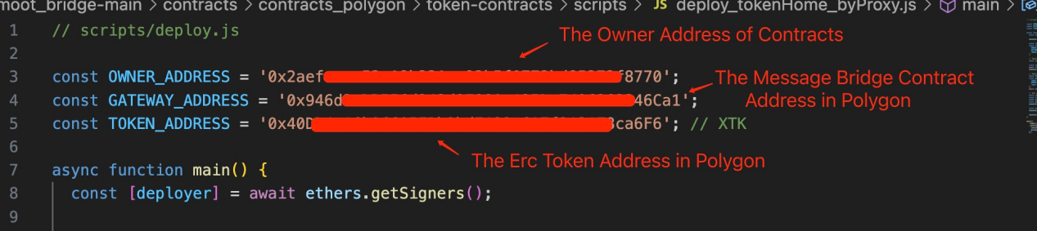

2.3.1.4 Deploy Contract
After the configuration information is confirmed above, then execute the
following command:

yarn hardhat --network polygonAmoy run scripts/deploy_tokenHome_byProxy.js

The depolyment of the TokenRemote contract in Ethereum

2.3.2.1 Install Dependency
cd ./contracts/contracts_ethereum/token-contracts/
yarn

2.3.2.2 Compile Contract
yarn hardhat compile

2.3.2.3 Update Script
After compile contracts, please change directory to “./contracts/contracts_ethereum/token-contracts/scripts/”，and update the script “deploy_tokenRemote_byProxy.js” as follows：
- The owner address used to deploy the contract;
- The address of message bridge contract you have deployed in 2.2.2;
- The Polygon’s TokenHome contract address you have deployed in 2.3.1;
- The mapping token address in Ethereum;

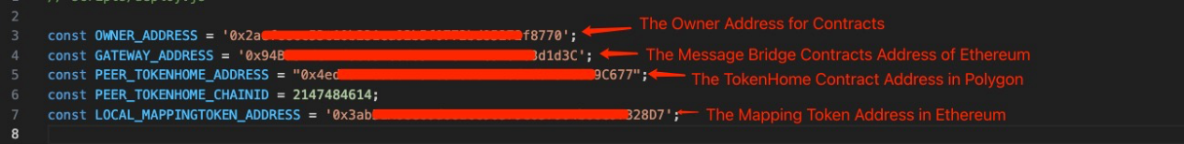

2.3.2.4 Deploy Contract
After the configuration information is confirmed above, then execute the
following command:

yarn hardhat --network sepolia run scripts/deploy_tokenRemote_byProxy.js

Configure the TokenRemote contract in Ethereum

2.3.3.1 Update Script
After compile contracts, please change directory to “./contracts/contracts_ethereum/token-contracts/scripts/”，and update the script “config_tokenRemote.js” as follows：
- The address of TokenRemote contract in Ethereum you have deployed in section 2.3.2;
- The address of TokenHome contract in Polygon you have deployed in section 2.3.1.
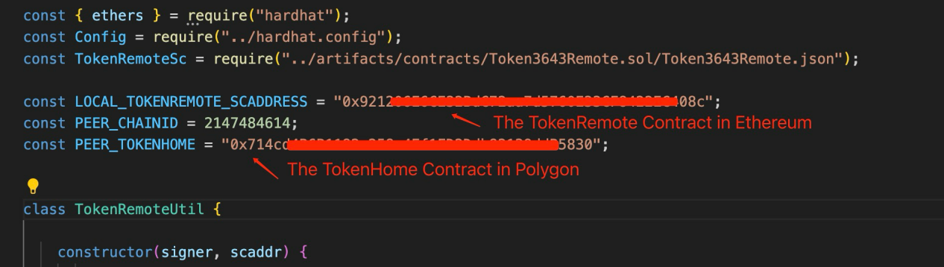

2.3.3.2 Configure TokenRemote Contract
After the configuration information is confirmed above, then execute the
following command:

yarn hardhat --network sepolia run scripts/config_tokenRemote.js

Configure the TokenHome contract in Polygon

2.3.4.1 Update Script
After compile contracts, please change directory to “./contracts/contracts_polygon/token-contracts/scripts/”，and update the script “config_tokenHome.js” as follows：
- The address of TokenRemote contract in Ethereum you have deployed in section 2.3.2;
- The address of TokenHome contract in Polygon you have deployed in section 2.3.1.
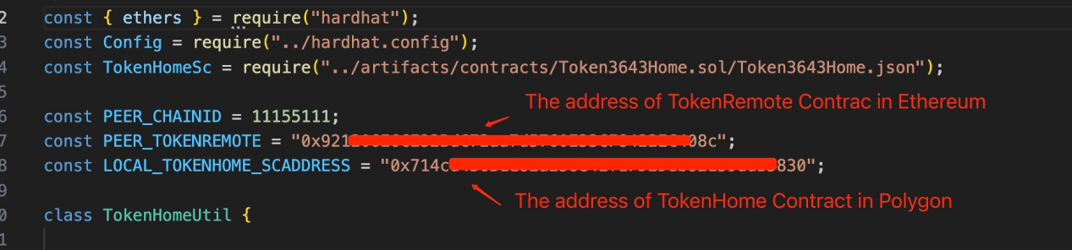

2.3.4.2 Configure TokenHome Contract
After the configuration information is confirmed above, then execute the
following command:

yarn hardhat --network polygonAmoy run scripts/config_tokenHome.js

(Optional) The Deployment of Token CrossChain Contracts From Ethereum to Polygon

This section is simalr to the section 2.3 but to support token to cross from Ethereum to Polygon, then need to deploy the TokenHome contract in Ethereum and it’s associated TokenRemote contract in Polygon.

The deployment of the TokenHome contract in Ethereum

2.4.1.3 Update Script
In Ethereum cmd termial, you need to change directory to “./contracts/contracts_ethereum/token-contracts/scripts/”，and update the script “deploy_tokenHome_byProxy.js” as follows：
- The owner address used to deploy the contract;
- The address of message bridge contract you have deployed in 2.2.2;
- The erc token address you want to support in Ethereum for crosschain.
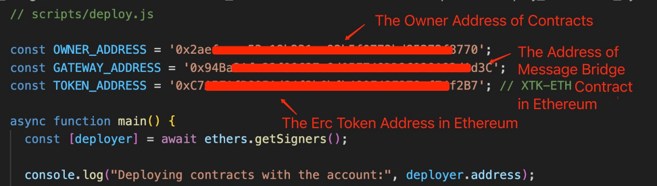

2.4.1.4 Deploy Contract
After the configuration information is confirmed above, then execute the
following command:

yarn hardhat --network sepolia run scripts/deploy_tokenHome_byProxy.js

The depolyment of the TokenRemote contract in Polygon

2.4.2.1 Update Script
In Polygon cmd terminal, you need to change directory to “./contracts/contracts_polygon/token-contracts/scripts/”，and update the script “deploy_tokenRemote_byProxy.js” as follows：
- The owner address used to deploy the contract;
- The address of message bridge contract you have deployed in 2.2.2;
- The Ethereum’s TokenHome contract address you have deployed in 2.4.1;
- The Mapping Token you in Polygon;
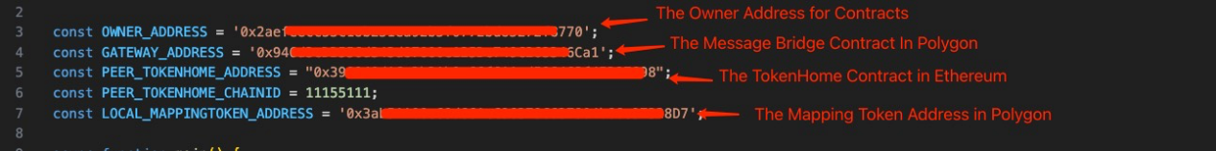

2.4.2.2 Deploy Contract
After the configuration information is confirmed above, then execute the
following command:

yarn hardhat --network polygonAmoy run scripts/deploy_tokenRemote_byProxy.js

Configure the TokenRemote contract in Polygon

2.4.3.1 Update Script
In Polygon cmd terminal, you need to change directory to “./contracts/contracts_polygon/token-contracts/scripts/”，and update the script “config_tokenRemote.js” as follows：
- The address of TokenRemote contract in Polygon you have deployed in section 2.4.2;
- The address of TokenHome contract in Ethereum you have deployed in section 2.4.1.
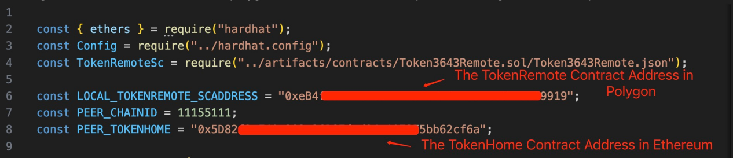

2.4.3.2 Configure TokenRemote Contract
After the configuration information is confirmed above, then execute the
following command:

yarn hardhat --network polygonAmoy run scripts/config_tokenRemote.js

Configure the TokenHome contract in Ethereum

2.4.4.1 Update Script
In Ethereum cmd terminal, you need to change directory to “./contracts/contracts_ethereum/token-contracts/scripts/”，and update the script “config_tokenHome.js” as follows：
- The address of TokenRemote contract in Polygon you have deployed in section 2.4.2;
- The address of TokenHome contract in Ethereum you have deployed in section 2.4.1.
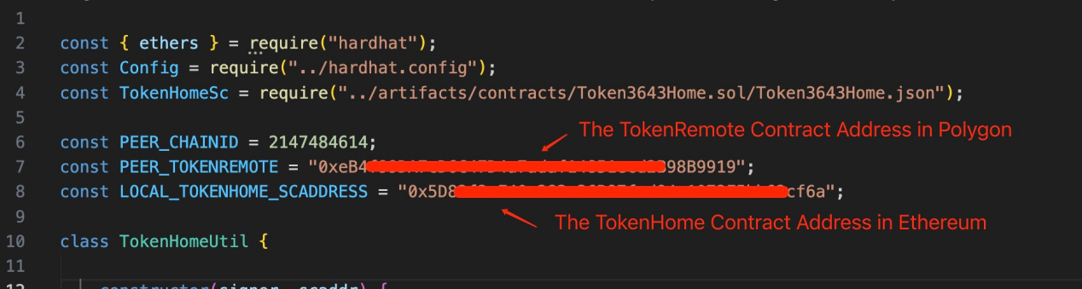

2.4.4.2 Configure TokenHome Contract
After the configuration information is confirmed above, then execute the
following command:

yarn hardhat --network sepolia run scripts/config_tokenHome.js

The Deployment of MsgRoute Service

Install Dependency
cd ./services/routeService_multiSig/
npm install

Update Configs
According to the section 1.4.1, you will update these publickeys of keyStores, which are prepared for your agents，into the config file as below:
./services/routeService_multiSig/conf/config.json
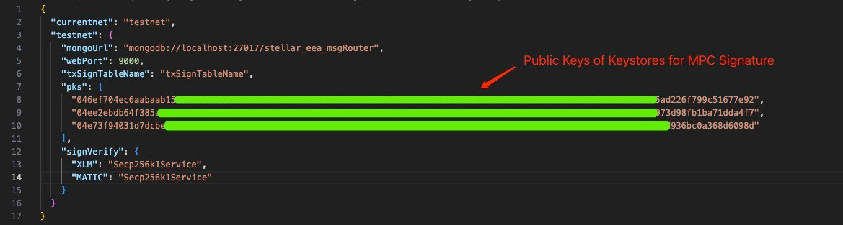

Run The Service
cd ./services/routeService_multiSig/src/
pm2 start startMsgRouter.js

The Deployment of Agents

Update Agent Configs

Update config.js
Based on the domain name you have applied for your server and the Nignx configuration, you will update the parameters in configuration file as below:
./agent/framework/config/config.js
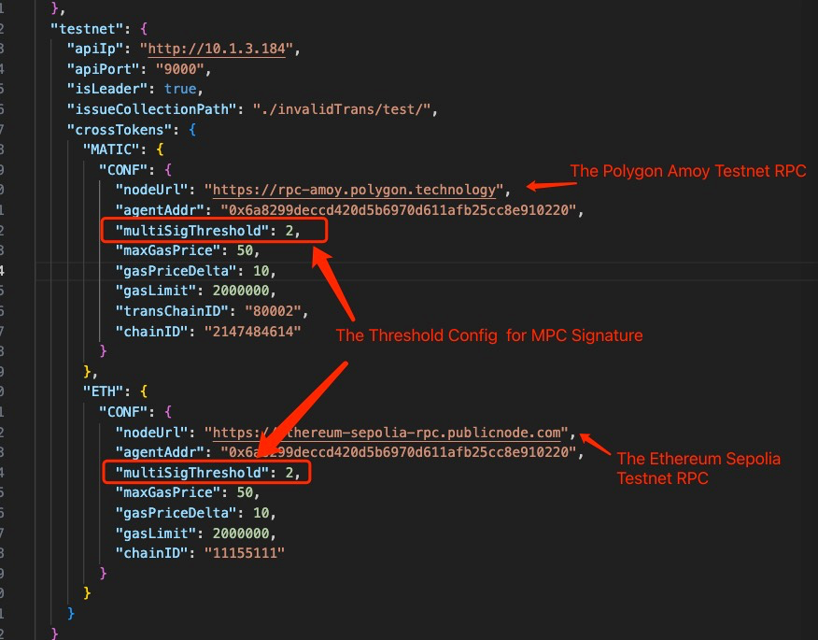

Update moduleConfig.js
According to the contracts deployment result in section 2, you need to update the parameters in the file:
./agent/framework/config/moduleConfig.js
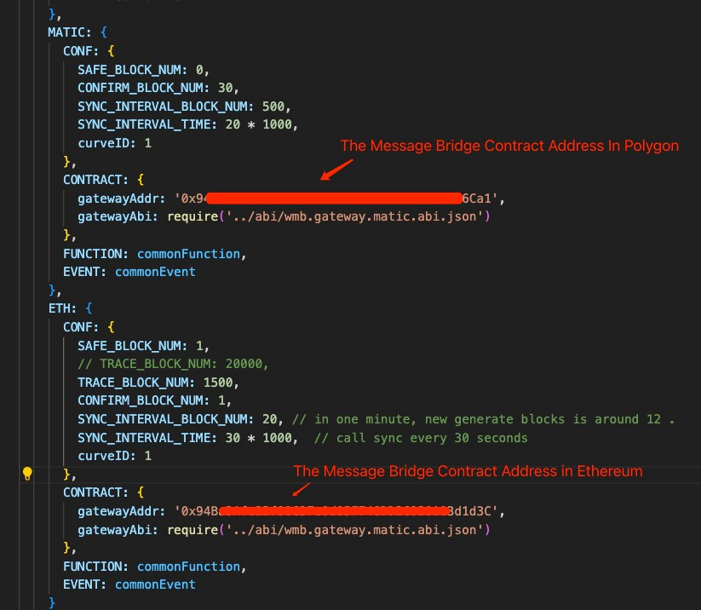

Update componet_config.js
Next step, you will update the wmbApp Convertor config:
./agent/modules/component_config.js

In our demo, we just support the token cross from Polygon to Ethereum, so justd to config the TokenHome contract in Polygon and the TokenRemote contract in Ethereum:
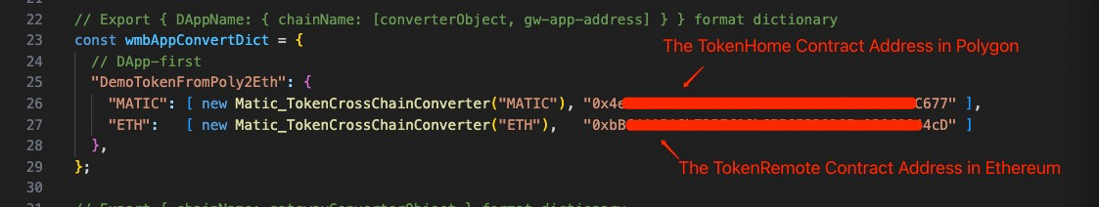

Deploy Agents

Unify The Deployment Path Config For Agents
In the directory of “./deployment/deploy_agent/script/”, you can change the deployment path for your agent nodes in these scripts: “deploy_agent.sh”、“startAgent.sh” and “start_container.sh”. And make sure the path must be same in these files.

- deploy_agent.sh
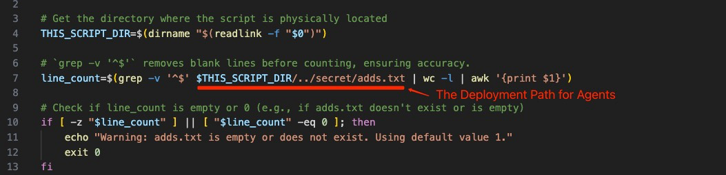

- startAgent.sh
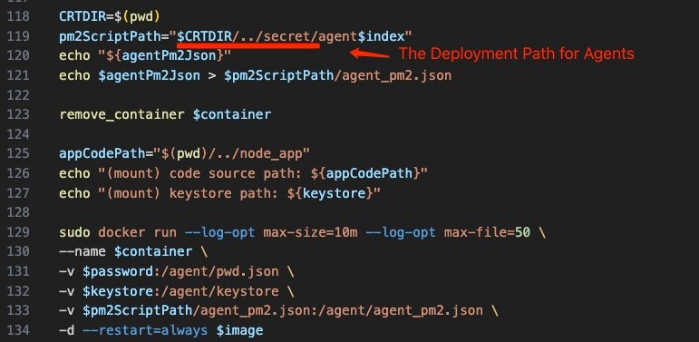

- start_container.sh
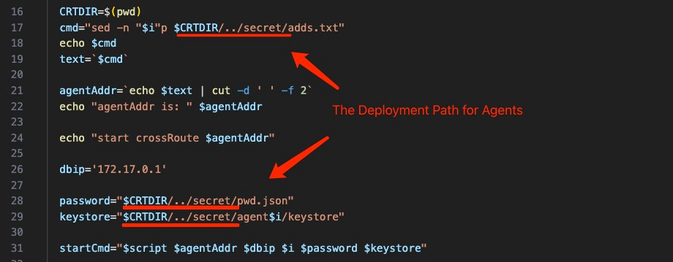

Prepare Accounts For Agents

Config Address for Agent
With the agents deployment path you have confirmed in section 4.2.1, take the default path “$CRTDIR/..secret/” as an example, you need to create a text file named “adds.txt”, and then fill in the account addresses assigned to agents you want to deploy.
Here we will take 3 agents as example, then the addresses will be configured in order from agent1 to agent3：
vim adds.txt

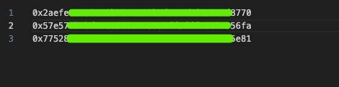

Config Password of Agent Account
Similar to the section 4.2.2.1, you need to create a text file named “pwd.txt”, and fill in the password for agent keystores:
vim pwd.txt

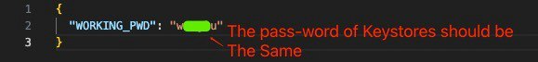

Assign KeyStore for Agent
In the agent deployment path confirmed in section 4.2.1, you will create folders for your agent nodes, with names should be “agent1”、”agent2” and “agent3”:
mkdir agent1 agent2 agent3

Then to create sub-folder in each agent folder with the name “keystore”, take the agent1 as example：
cd agent1
mkdir keystore
Based on the accounts assigned result in section 5.5.1.1, then you need to put the keystore files, which have been prepared in Section 1.2, into the corresponding agent's keystore folders, make sure different keystore for each agent and the agent1 will be the Leader.

Run Agents

Build Agent Docker Image
Since all these steps above have been done, then you can build docker image for your agents:

cd ./deployment/deploy_agent/script/
bash buildDocker.sh

Start Agents
Then you run docker instance for your agents:

cd ./deployment/deploy_agent/script/
bash deploy_agent.sh

The Bridge
https://smoot-demo.vercel.app/

